## Canteen Ordering System for Unilever

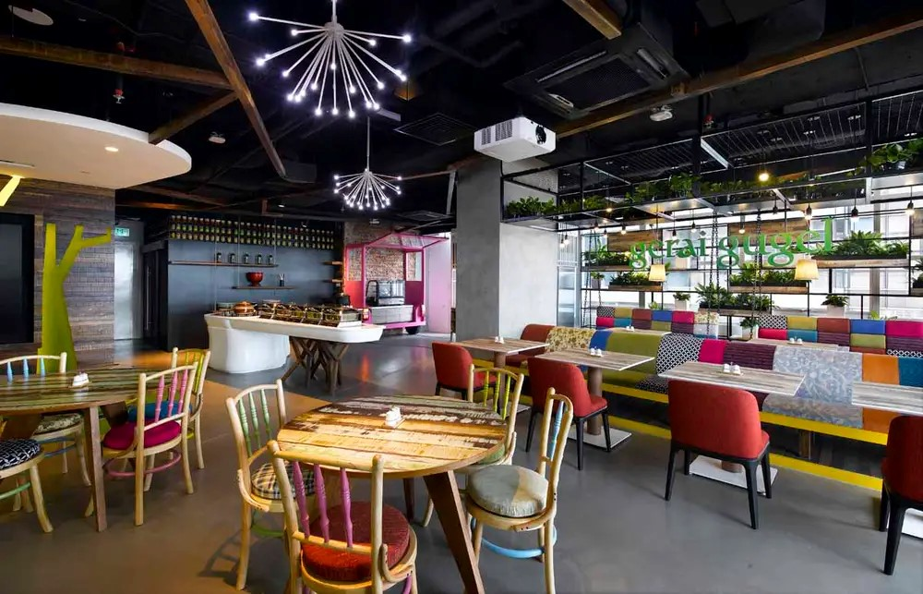

**Simplilearn CBAP Certification**

**Project- I**

**By- Sanika Sheth**

Description

**Current State**

**Overview and Summary**

Unilever is a British-Dutch MNC FMCG company, headquartered in London, England. Unilever is one of the oldest FMCG companies, and its products are available in around 190 countries. In its UK offices, Unilever had around 1500 employees which were spread across 12 floors. They had 2 canteens to cater to these 1500 employees. Each canteen could seat around 150 employees at a time.

Most employees would prefer to take their lunch between 12 noon to 1 pm. This led to a huge rush in the canteen during lunch hours resulting in employees wasting a lot of time waiting for tables to be vacant.

Management calculated that it took around 60 minutes for employees to go and come back from lunch. Almost 30-35 minutes were wasted in waiting in a queue to collect their food and get a table to sit and eat. However, the time spent eating was barely 10-15 minutes. The remaining 10 minutes were spent reaching and coming back from the canteen using the elevators.

Employees don’t always get their choice of food they want because the canteen runs out of certain items. The canteen wastes a significant quantity of food by throwing away what is not purchased.

Many employees have requested a system that would permit a canteen user to order meals online, to be delivered to their work location at a specified time and date.

**Advantages of the Canteen Ordering System:**

* A system would save considerable time to those employees who use the service.
* It would increase the chance of them getting the food items they prefer.
* This would improve both their quality of work life and their productivity.
* The food wastage will be reduced.
* This will reduce the cost.

The client invited Business Analysts trained at Simplilearn to capture the requirements to create the Canteen Ordering System.

**Environments**

We are going to be creating and maintaining the program in Java. We chose Java because it will not change much over time, and if we make it well, there will be very little maintenance to be done on the code.

**Business Objectives and Success Criteria**

**Business Objective 1:**

Reduce canteen food wastage by a minimum of 30% within 6 months following first release.

Scale: Value of food thrown away each month by examining the canteen inventory

* Previous - 25% wasted
* Must plan for: Less than 15%

**Business Objective 2:**

Reduce canteen operating costs by 15% within 12 months, following initial release.

**Business Objective 3:**

Increase average effective work time by 30 minutes per employee per day, within 3 months.

**Business Objective 4:**

By making the ordering process automated and by delivering the food to the user's workstation, the canteen will be able to operate with lesser manpower.

**Future State**

**Client has given them the following requirements:**

1. The employee shall open the web page of the Canteen Ordering System. He/she shall be presented with an up-to-date menu for the day. It will have a list of all the dishes available in the canteen for the day along with its prices.
2. The lunch order can be placed by employees latest by 11 am. After 11 am the system shall not allow the users to place orders for lunch items so that the chefs have sufficient time to cook the ordered dishes. There should be a Menu Manager (a canteen employee) who shall create the menu and update the menu.
3. The users can select the lunch dishes they would like to eat and create an order. They should be able to edit the items they want to order anytime before checking out.
4. Once the order is confirmed and the user has checked out, they should **NOT**be able to cancel or edit the order.
5. The canteen manager also known as order processor should be able to view the orders placed by the employees. He shall take an inventory of all the dishes ordered by different users and get them cooked by the chef.
6. This canteen manager should be able to request a delivery to the employees’ workstation.
7. There shall be a meal deliverer (delivery boy) who shall deliver the lunch to the employee's desk. After delivering the lunch, this delivery boy shall close the online customer order.
8. If a customer does not like any food item or is not happy with the delivery system by the canteen, they should be able to submit feedback.
9. There is no payment gateway for the same so the payment for dishes ordered shall be deducted from employee’s salary. Hence, the employees need to enroll for salary payment deduction. The payroll system will handle payroll deductions.
10. At the end of the month the payroll system shall calculate the total number  of dishes ordered by each employee. The payroll system shall deduct money  from the employee’s salary.
11. Management would like the following reports:

* Which dishes are the most popular?
* How many employees are using the system?
* Satisfaction of the employees on using the system. This should be tracked on the basis of feedback submitted by the employees.
* Sales for each day
* Total monthly earnings
* Order forecasting i.e. a prediction of which items will be ordered and when they will be ordered.

**System Requirement:**

Scalability and performance:

This canteen ordering system is required to support a volume of 1500 employees ordering. the web pages should be light and render fast.

**Usability:**

The screens should be self-explanatory and very user friendly. Management would not want employees not ordering from the system as they cannot understand the screens and data fields on screen.

**Project Task:**

1. Identifying stakeholders – Create a list of stakeholders (as taught in Business Analysis Planning and Monitoring Knowledge Area)
2. Identify the problem statement in this system.
3. Identify objectives of the new Canteen Ordering System.
4. Create as-is and future process map (using flowcharts). You can use any of the popular tools in the market like Microsoft Visio, Lucid Chart, Creately, Pidoco, or Balsamiq
5. As a Business Analyst working on this project, find out the scope of the Canteen Ordering System. To find the scope you can use the case diagram (UML) or context diagram for the same.
6. Write down the main features that need to be developed.
7. Write the in-scope and out-of-scope items for this software.
8. Draw an activity diagram for the system.
9. Draw an ER diagram of the system.
10. Write out the business requirements, both the functional and nonfunctional requirements.
11. Draw wireframes or mock screens for any two of the features namely Menu Creation and any other feature as deemed fit by the student. (Use the technique prototyping or wire framing that is taught in the Training). You can use any of the wireframing tools like Microsoft PowerPoint, Microsoft Word, Balsamiq, Sketch, Adobe XD, Adobe Illustrator, Figma, UXPin, InVision Studio, InVision Freehand, or Moqups.

**Stakeholders**

|  |  |
| --- | --- |
| **ACTOR** | **What they can do on the software created** |
| Employee/Customer | * The employees should be able to open the web page of the Canteen Ordering System to place the lunch order. * The employees should be presented with an up-to-date menu for the day with a list of dishes and its prices. * The employees can select the lunch dishes they would like to eat and create an order. They should be able to edit the items they want to order any time before checking out . * Once the order is confirmed and the employee has checked out, they should not be able to cancel or edit the order. * The order status should be displayed after placing it on the application and it should tell the customer by when (i.e date and time) it would be delivered to their work location. * If a customer does not like any food item or is not happy with the delivery system of the canteen, they should be able to submit feedback. * Since there is no online or offline payment option, the employees should be able to enroll for deduction from their salary using the payroll system. |
| Canteen Manager | * The canteen manager should be able to view the orders placed by the employees and then take an inventory of all the dishes ordered by different employees and get them cooked by the chef. * Should be able to request a delivery to the employees’ workstation |
| Delivery Boy | * He should be able to deliver the lunch to the employee's desk . * After delivering the lunch, he should be able to close the online customer order |
| Payroll system | * The payroll system should have adequate capability to calculate the total number of dishes ordered by each employee and store this information in the database. Also, it should be able to deduct the money from the employee’s salary. * If there are leavers and joiners in the firm, the payroll system should be able to update this information in its record |
| Management | * They should be able to gather the below information and analyze the following: * Which dishes are the most popular? * How many employees are using the system? * Satisfaction of the employees on using the system. This should be tracked based on feedback submitted by the employees * Sales for each day * Total monthly earnings * Order forecasting i.e. a prediction of which items will be ordered and when they will be ordered. |

**Problem Definition and Solution**

* Space for 1500 employees not available in canteens
* Time wastage of employees in going and coming back from lunch
* Employees not able to get food as per their preference due to insufficient quantity available
* 30-35 min wastage per employee which means 45000 employee minutes wastage per day
* Food wastage
* Operating cost is more as required

**Advantages and Objectives**

* A system would save considerable time to those employees who use the service
* It would increase the chance of them getting the food items they prefer
* This would improve both their quality of work life and their productivity
* The food wastage will be reduced
* This will reduce the cost

**Objectives**

* Reduce canteen food wastage by a minimum of 30% within 6 months following first release. •
* Reduce canteen operating costs by 15% within 12 months, following initial release.
* Increase average effective work time by 30 minutes per employee per day, within 3 months.
* By making the ordering process automated and by delivering the food to the user's workstation, the canteen will be able to operate with lesser manpower.

**Existing System**

* **As in flow diagram using Lucid chart**

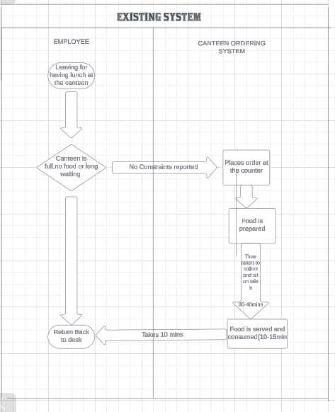

**Proposed System**

* User friendly interface
* User can edit an existing order or cancel or confirm the order easily
* User can provide feedback after having lunch
* Manager can check the status of food being prepared and track if delivery boy has delivered the food
* Payroll system will automatically deduct from the salary for every confirmed order

**Scope using *Context diagram***

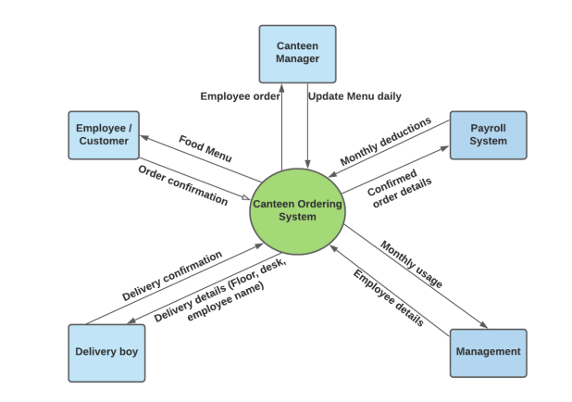

**In Scope**

* ● Payroll system registration for employee
* Login screen on portal for employee
* User authentication on portal if enrolled for lunch
* Display menu page
* Meal ordering screen with option to place and confirm order to be available only till 11 am ● Order confirmation
* Feedback submission by employee
* Details of the confirmed order that includes menu item, time of order and price
* Order status
* Contact details of delivery boy for any guidance (i.e if you are not at desk)
* Delivery closure once delivery boy completes the order
* Payroll deduction ● Monthly sales report for orders placed Out of Scope
* Any employee who is not part of Unilever for canteen ordering system
* This canteen operation system will be operational only during lunch time (12PM to 2PM). Any time beyond it will be considered out of scope
* Employees not having valid credentials
* 1 order per person. More than 1 order will be out of scope
* Refund for incorrectly placed orders
* Food supplies in stock and impact of food inflation on the prices

**Out of Scope**

* Any employee who is not part of Unilever for canteen ordering system
* This canteen operation system will be operational only during lunch time (12PM to 2PM). Any time beyond it will be considered out of scope
* Employees not having valid credentials
* 1 order per person. More than 1 order will be out of scope
* Refund for incorrectly placed orders
* Food supplies in stock and impact of food inflation on the prices

**Activity Diagram for the System:**

* Flow diagram prepared using Lucidchart

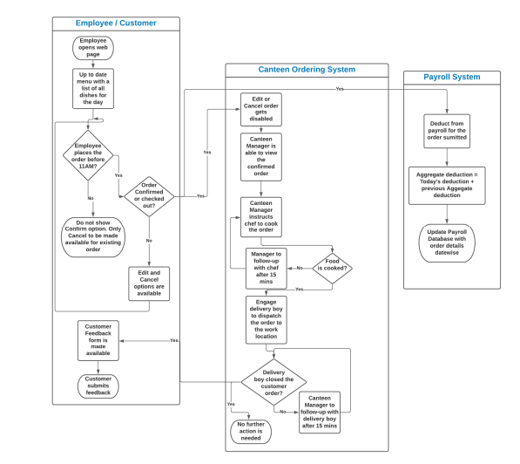

**ER Diagram for the System:**

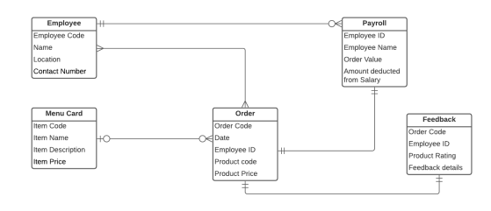

**Business Requirements:**

1. **Business Objective 1**: Reduce canteen food wastage by a minimum of 30% within 6 months following first release. a. Scale: Value of food thrown away each month by examining the canteen inventory b. Previous - 25% wasted c. Must plan for: Less than 15%
2. **Business Objective 2**: Reduce canteen operating costs by 15% within 12 months, following initial release.
3. **Business Objective 3**: Increase average effective work time by 30 minutes per employee per day, within 3 months.
4. **Business Objective 4**: By making the ordering process automated and by delivering the food to the user's workstation, the canteen will be able to operate with lesser manpower.

**Functional Requirements**

* Employees should be able to enroll for salary deduction
* User registration using SSO that should display the menu details on the webpage
* System should allow to place/modify orders till 11AM only
* Once order gets confirmed, do not display option to edit or cancel the order
* Canteen manager should be able to check order status and click on dispatch delivery to workstation on the web page
* Delivery boy should be granted access to close customer order
* Feedback mechanism needs to be activated for the customer/end user once the delivery is closed • Creating and maintaining the program needs to be done using Java
* Every month end Payroll system should display all the orders placed during the month and display the amount to be deducted from the salary

**Nonfunctional Requirements**

* Device compatibility exists with Windows, MAC and other OS when application is built
* Adequate capacity to cater to 1500 employees when they get connected on the web page
* There are no jargons, and the fonts/texts are readable in dim light
* Canteen Ordering should be available during office hrs as employees could work on weekends or public holidays, so ensure SLO exists if support needs to be engaged for incidents

**System Requirement:**

* Should work on Java Platform
* Should be compatible with all the OS in the firm, say Windows, MAC, etc
* System will auto-create monthly reports to include monthly earnings and order forecasting based on what dishes are the most popular

**Usability:**

* Should be fit for purpose and fit for use
* There are no jargons, and the fonts/texts are readable in dim light

**Environments:**

* Canteen Ordering should be available during office hrs as employees could work on weekends or public holidays, so ensure SLO exists if support needs to be engaged for incidents

